Stakeholder Experiences and Perspectives of the Nueva Escuela Mexicana Reform in Mexican Primary Education
Dr Nozomi Sakata, Hiroshima University, Japan
Dr Nicholas Bremner, University of Exeter, UK
Dr Lilia Sulema Bórquez Morales, Universidad Autónoma del Estado de México, Mexico

KEY FACTS
Policy area: Primary education reform in Mexico
Research question: What are stakeholder experiences and perspectives of the Nueva Escuela Mexicana reform in primary education?
Methods: 79 interviews with students, teachers, parents, head teachers, teacher trainers and supervisors in 12 primary schools in three Mexican states

Funded by: Japan Society for the Promotion of Science (¥15,470,000JPY; ~£75,000GBP; ~$1,750,000MXN)

Dates: November 2023 - January 2024

Research stage: Completed

Summary of the research
In the 2023-2024 school year, Mexico started implementing the Nueva Escuela Mexicana (NEM) in Basic Education. This educational reform represents a large shift in curriculum, pedagogy and assessment, notably:
- Combining school subjects such as maths and science into integrated “formative fields”;
- Focusing on meaningful learning that places more value on local communities;
- An emphasis on active and interactive learning through projects;
- An increased emphasis on topics related to inclusion and diversity;
- Increased autonomy for teachers and schools to adapt to local contexts.
The NEM has been met with both enthusiasm and scepticism. This research is one of the first to comprehensively gather stakeholder experiences and perspectives of the NEM in its first full year of implementation. Researchers from Japan and the United Kingdom conducted a total of 79 interviews with a total of 168 students, teachers, parents, head teachers, teacher trainers and supervisors in 12 primary schools (urban, semi-rural and rural) in three states: Nuevo León, Hidalgo and Chiapas.

Policy recommendations
- Provide more concrete training and support (especially in terms of supporting teachers to manage increased autonomy), with a more consistent, unambiguous communication strategy.
- Address stakeholder concerns about gaps in foundational knowledge – consider the extent to which students may need basic knowledge in order to develop higher order skills.
- Strengthen communication with parents and the wider public to make it clear what NEM does and what it does not do (despite some attempts to raise societal awareness of the reform, many parents were still very unclear on the aims and pedagogical approaches of the NEM).
Key findings
- More emphasis seems to have been placed on the “what” (the content of the reform itself), and much less on the “how” (how to implement the reform).
- Stakeholders tended to value active and interactive learning through projects, but were very concerned about the lack of “foundational” knowledge many of their students had. Relatedly, there was a lot of scepticism regarding combining specific school subjects into “formative fields”.
- Stakeholders were generally very supportive of content related to inclusion and diversity (e.g. of indigenous peoples) but expressed doubts about certain topics (e.g. content relating to gender and sexuality).
- Stakeholders were generally happy with the notion of “focusing on the local”, contextualisation and teacher autonomy. However, some teachers did not always know how to manage such autonomy, requesting more explicit guidance.
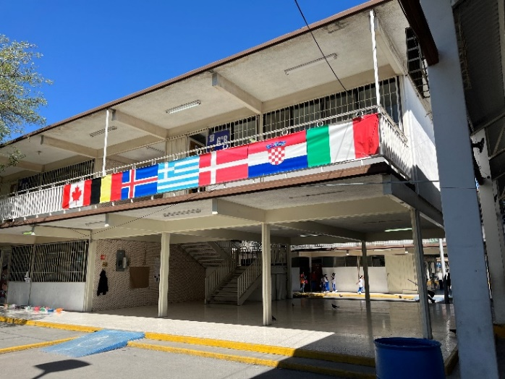
- There was widespread uncertainty about the NEM reform. Although teachers, head teachers and teacher trainers were getting used to the changes over time, they lamented inconsistent policy messages and a general lack of explicit support.
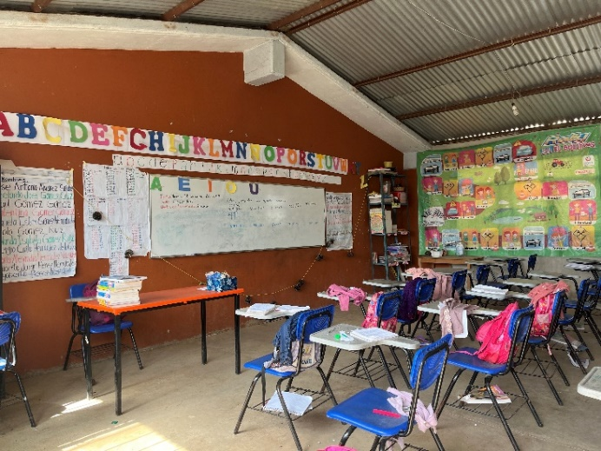
Further information
The article summarising this study is currently undergoing a process of academic peer review. A selection
of excerpts from interviews are provided on the following pages.

For more information about the project, please contact:
- Dr Nozomi Sakata (in English) at sakatan@hiroshima-u.ac.jp.
- Dr Nicholas Bremner (in English or Spanish) at n.bremner@exeter.ac.uk.
- Dr Lilia Sulema Bórquez Morales (in English or Spanish) at liliaborquez.morales@gmail.com.
A range of positive and negative views on the Nueva Escuela Mexicana
The concept of the New Mexican School is still in the process of being assimilated.
(Head Teacher 12, rural Chiapas)
I really don’t know what this new plan is like. I mean, we have to give it a chance.
(Parents FG5, urban Hidalgo)
It is a difficult task; it is a challenge; but I believe that step-by-step we are going to achieve it.
(Local Teacher Trainer 1, urban Nuevo León)
Yes, we still have to make adjustments, […] but the general view, I think, is positive.
(Local Teacher Trainer 2, urban Hidalgo)
It is a failure, this pedagogical model.
(Teacher 20; rural Chiapas)
There is a lot of reluctance in half of my colleagues.
(Head Teacher 9, rural Chiapas)
I liked the other previous methodologies more.
(Teacher 11, semi-rural Hidalgo)
I don’t think it’s such a positive change […] compared to previous programmes.
(Teacher 1, urban Nuevo León)
Like everything else, it has good things, it has bad things.
(Parents FG8, semi-rural Hidalgo)
I feel that with this New Mexican School, it’s going to be worse.
(Local Supervisor 1, urban Nuevo León)

At the beginning there was a lot of reluctance about the textbooks. […] I looked at them and said “look, this is good, look, this is positive; there are bad things but there are also good things”.
(Local Teacher Trainer 1, urban Nuevo León)
I think that what they are doing right now is correct.
(Head Teacher 4, rural Nuevo León)

I like the new educational model.
(Parents FG8, semi-rural Hidalgo)

The change is very positive.
(Teacher 23, urban Chiapas)

Active, project-based approaches are valued, but concerns about students’ lack of “foundational” knowledge and the removal of specific subjects
The only thing I would like to change in school is that we go back to the old books. […] The information now is more scrambled, […] whereas the earlier books gave clearer information so that you understood what you had to do.
(Pupils FG22, urban Chiapas)

We would like to have more projects, for example, more presentations. […] Because we like to work as a team.
(Pupils FG9, urban Hidalgo)

It was better before. […] We get very confused when we take out the textbooks.
(Pupils FG11, semi-rural Hidalgo)

I haven’t touched the books. […] I am going to go at my own pace and at the pace of my children.
(Teacher 17, rural Chiapas)

With this New Mexican School, I still feel more lost. […] it’s “half-understood”; “half-learnt”.
(Head Teacher 2, urban Nuevo León).

If my child doesn’t know how to read, how am I going to apply this project?
(Teacher 13, rural Hidalgo)

The projects are very cool, very fun, I like them a lot. […] But for that, I tell you, they need to be able to read and write.
(Head Teacher 3, urban Nuevo León)

Essential learning: Spanish and mathematics […]; the basics, is something that does not come in the projects.
(Teacher 7, rural Nuevo León)

I really like the projects, because sometimes the teacher gets us to work in teams.
(Pupils FG3, urban Nuevo León)

We made a recipe. […] I liked that activity very much because I was with my friends, we got into teams, each one brought a recipe, we wrote, drew, painted.
(Pupils FG18, rural Chiapas)

Before it was more theoretical. […] Now with all these projects, I feel that they are making them do more than just theory, and I feel that this is very good for the children.
(Parents FG6, semi-rural Hidalgo)

I saw a lot of understanding after they did all those activities, […] I feel that it stayed with them more than in other activities.
(Teacher 8, rural Nuevo León)

I like project work. […] I see how the students are doing, and I love it.
(Teacher 5, urban Nuevo León)

Inclusive approaches are valued, but concerns regarding specific curricular content (in particular gender and sexuality)
We can’t just learn from ourselves. […] It is very important […], that they feel that they are part of here […] but also that they feel that it is not the only thing in the world.
(Parents FG11, urban Chiapas).

Our Mexico is rich, rich in culture. […] the need to value all that diversity of cultures.
(Head Teacher 5, urban Hidalgo)

I feel that this does not apply so much to Nuevo León […] where it is very rare to meet [indigenous people]. It is more frequent to meet people who speak in English. […] The [indigenous] languages are not very relevant.
(Parents FG2, urban Nuevo León)

We are told many things in books that are not really historically accurate. […] We lack the culture of understanding who we are.
(Parents FG5, urban Hidalgo)

I think it is very positive, because it is a way to re-value ourselves and, above all, to promote respect and equality.
(Teacher 8, rural Nuevo León)

We are trying to rescue what has been lost, for example the indigenous languages.
(Head Teacher 6, semi-rural Hidalgo)

Some of the books deal with what we call “gender ideology”. And Mexico is a very conservative culture. […] That’s why many of us opposed the implementation of the books.
(Local Teacher Trainer 1, urban Nuevo León)

Some parents don’t want the books, precisely because of the topic of sexuality. […] I don’t agree that it should be seen at such a young age.
(Parents FG11, urban Chiapas)

There are many issues that the new books bring that are controversial. […] So here we don’t do it [teach topics related to gender and sexuality]
(Teacher 23, rural Chiapas)

Rescuing our culture, well that is what gives us our identity.
(Teacher 11, semi-rural Hidalgo)

[The NEM reform] gives importance […] not only to scientific knowledge but also to “popular” knowledge, of ancestral knowledge.
(Head Teacher 8, semi-rural Hidalgo)

I think it is very important for our children to understand where we come from our history.
(Parents FG5, urban Hidalgo)

Mexico has always obeyed other educational systems […]. We copy their system from other countries and that’s the problem.
(Head Teacher 12, rural Chiapas)

Contextualised approaches are valued, but increased autonomy is challenging for some teachers
The New Mexican School gives us an autonomy that the teacher is not used to, so they don’t know what to do.
(Head Teacher 12, rural Chiapas)

I’m going to teach your children, but according to what they know; contextualise it; make it easier. That’s what I like about the New Mexican School.
(Teacher 10, urban Hidalgo)

I feel that we have become so accustomed, to everyone telling us what to do, that now that they tell you “I'll give you the freedom to do it” we suddenly feel like we have no points of support. […] There can be a transition towards autonomy, but I think a gradual implementation works better, […] with the necessary support.
(Head Teacher 8, semi-rural Hidalgo)

You had to follow a curriculum. […] Now I feel that there is a lot of freedom. […] Before I felt under pressure because they had to reach a certain point by a certain time.
(Teacher 8, rural Nuevo León)

It’s like “do whatever you can” or “whatever you want”. […] We teachers are not political agents.
(Teacher 1, urban Nuevo León)
Previously the books were more structured and now it’s a bit […] disorganized. […] It’s too much chaos.
(Parents FG11, urban Chiapas)

There’s so much freedom. A lot of times you lose the focus. […] That’s why I think many teachers feel lost.
(Teacher 2, urban Nuevo León)

We are a little bit too dependent. We are more “technical” than “professional”, because we expect them to tell us what we are going to do.
(Teacher 15, semi-rural Hidalgo)

I don’t think the books are bad; I think they come with many possibilities for the teacher to decide what he or she can and can’t do.
(Teacher 6, urban Nuevo León)

What I like is precisely that, that they leave it up to the teacher.
(Parents FG11, urban Chiapas)

I think that’s what I like most about this new reform, which gives you as a teacher the freedom to see that this works for my children and this doesn’t, and you can modify it.
(Teacher 23, rural Chiapas)

Widespread uncertainty, inconsistent policy messages and a lack of explicit support
They don’t call us up to support us. […] They just give you […] 7 or 8 little sheets that are very general. […] I would prefer much more clarity on what steps have to be taken.
(Head Teacher 7, rural Hidalgo)

There is a paradigm shift; there is a change in the approach to education. But there has been no real systematisation of teacher training.
(Local Supervisor 3, rural Chiapas)

I think that the new Mexican school is excellent; it just wasn’t well planned. (Head Teacher 1, urban Nuevo León)

Each six-year term brings its own reform. […] They don’t give us a chance to see if there are results.
(Teacher 11, semi-rural Hidalgo)

Every six years the educational model changes. […] There is no continuity of the same educational model. […] There is no clarity; no goal.
(Teacher 18, rural Chiapas)

We started to be updated on a drip-feed basis. […] The information either arrived too quickly for us to transmit it, or it arrived late, or it didn’t arrive at all. You asked the corresponding educational authority, and they didn’t know either. […] I would say it is not consistent, and at many times it is not coherent.
(Local Supervisor 2, rural Nuevo León)

They told us one thing in one training day, and then something else in the other, and then something else in the other.
(Head Teacher 3, urban Nuevo León)

They gave us the books to read, but there was no person from above who told us “the reform consists of this”, as in all the previous reforms. […] I can tell you that out of 10 teachers, 8 don’t understand the reform.
(Local Teacher Trainer 1, urban Nuevo León)

It is really a bit difficult for us in the sense that there was no training as such. […] We were told, “here’s your programme - now we are going to implement it”.
(Teacher 19, rural Chiapas)

